INTRODUCTION TO CLOUD COMPUTING Lab
Task 09 (C) (Administer PaaS Compute Options)

Name: Arshia M Ali
ID: 2280140
Section: BSSE 7-B

Task 1: Create and configure an Azure Container App and environment.
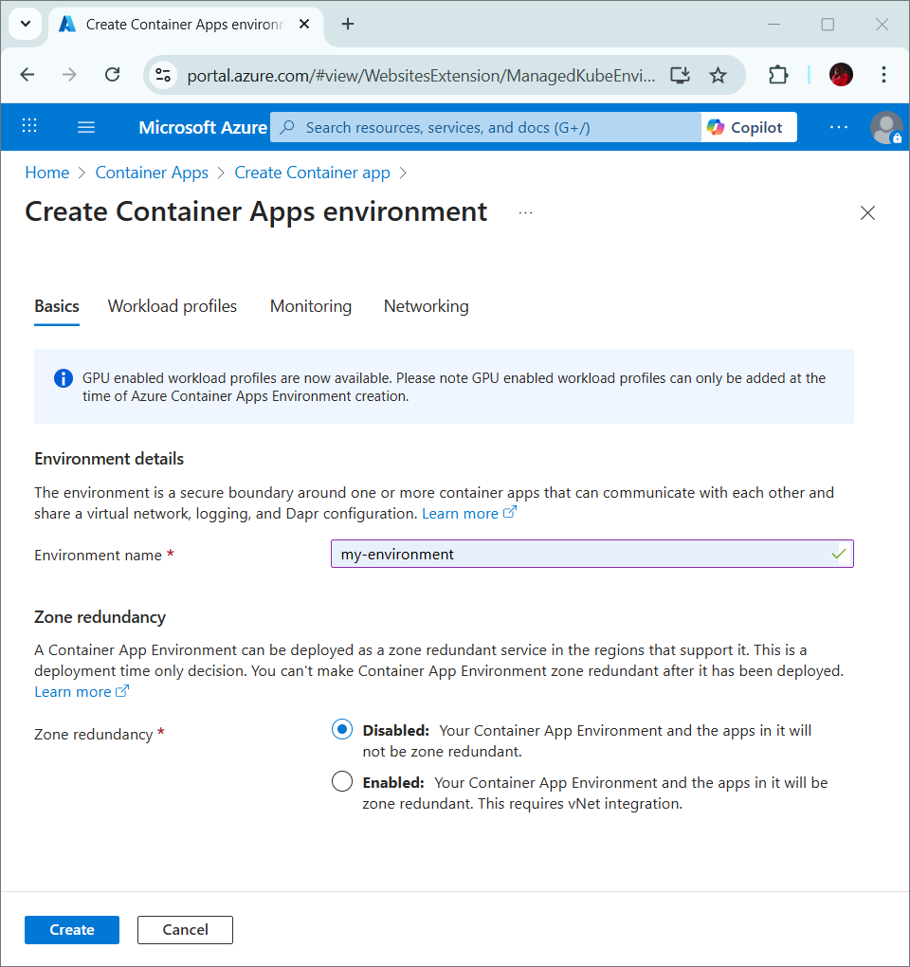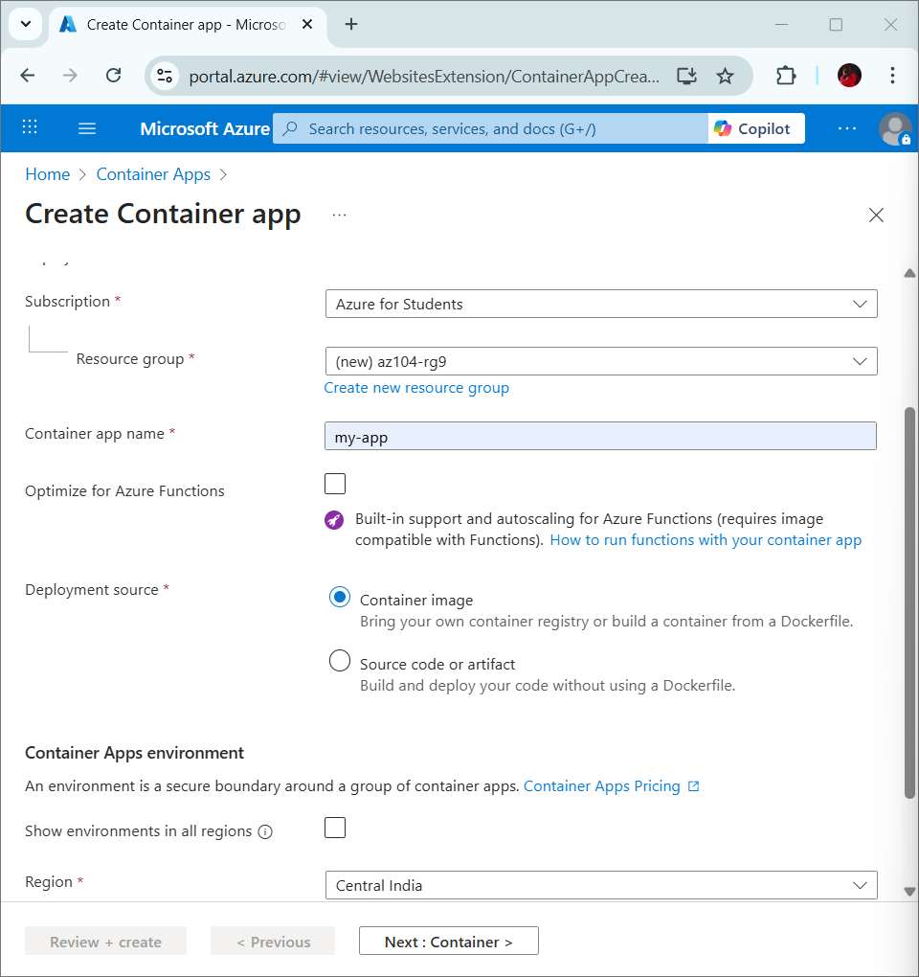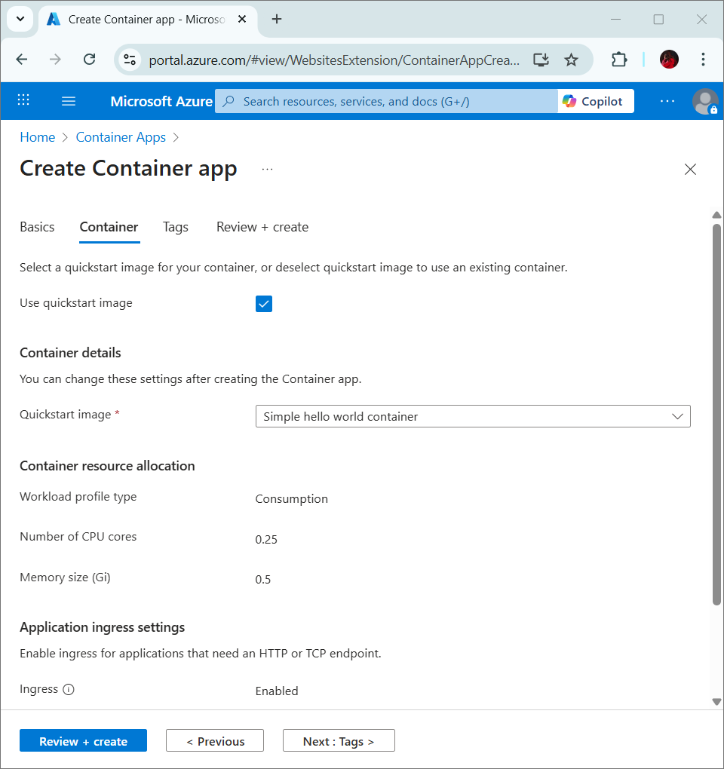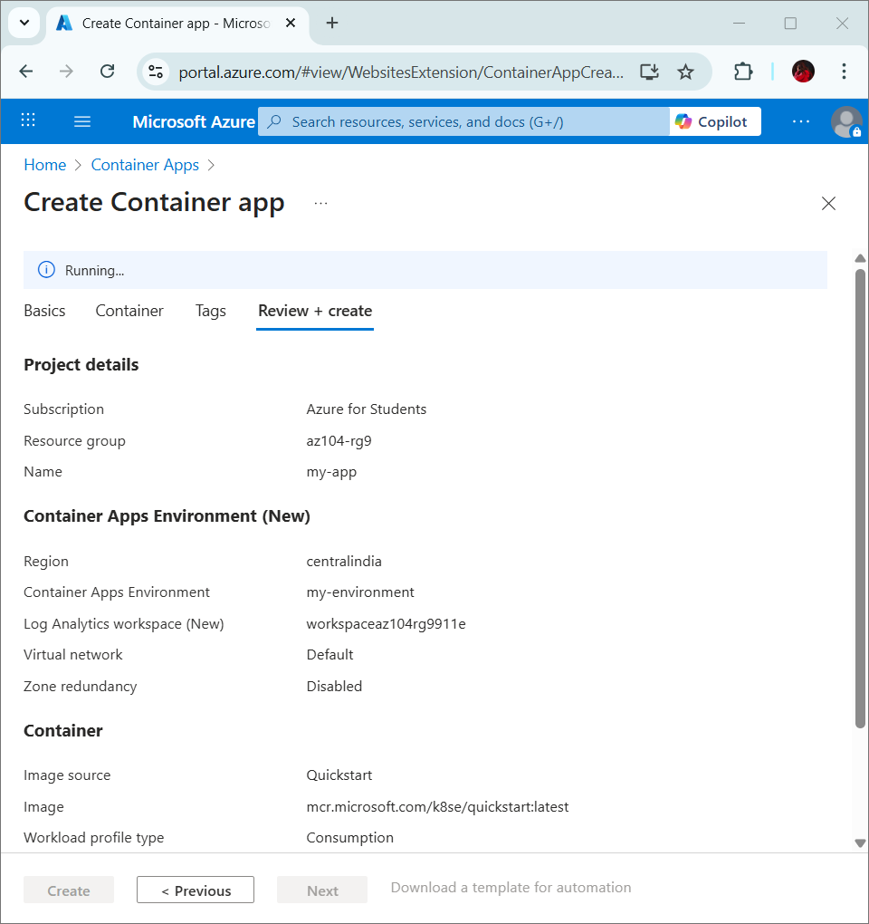
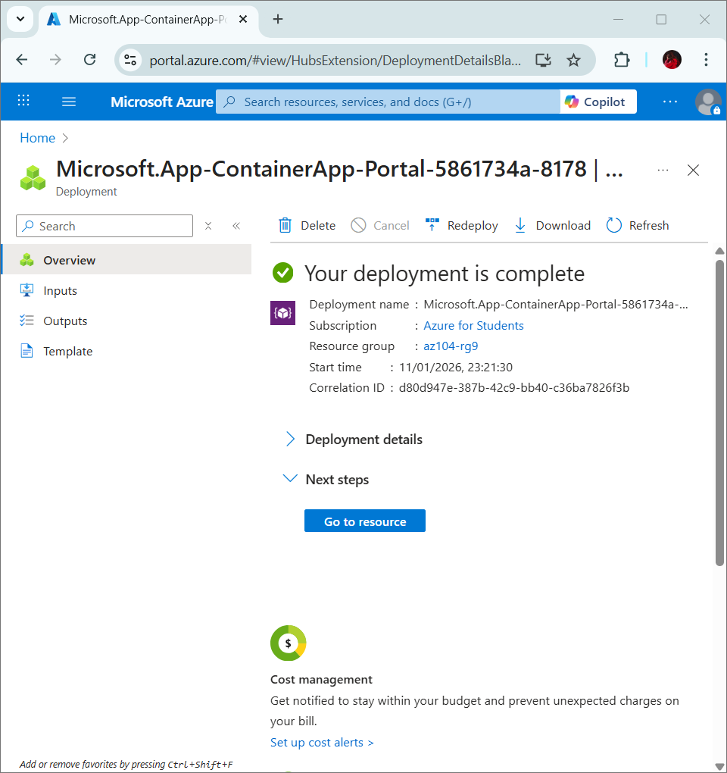

Task 2: Test and verify deployment of the Azure Container App.
